Chapter II: Overcoming Local Network Limitations with Firebase

General Process
The objective of this chapter is to solve the limitation identified in Chapter 1, where the ESP32 web server is accessible only within the same local network. By using Firebase, a cloud service, we can access our data from anywhere in the world, even when we’re not connected to the same router. This chapter covers two mini-projects demonstrating how Firebase allows us to overcome these limitations.
1. Cloud Computing and Firebase
1-1. Understanding Cloud Computing
Cloud computing involves delivering various computing services like storage, databases, servers, networking, analytics, and software through the internet. Instead of relying on local hardware, users access these services online, providing flexibility and scalability. Key characteristics of cloud computing include:
- On-Demand Access: Access cloud services anytime, anywhere, with an internet connection.
- Scalability: Resources can be adjusted based on demand, allowing for flexibility.
- Cost-Efficiency: Reduces costs associated with hardware, maintenance, and infrastructure.
- Security: Cloud providers use robust security protocols to ensure data safety.
- Collaboration: Cloud services facilitate collaboration among users and devices across different locations.
1-2. Introducing Firebase
Firebase, a cloud service by Google, is designed to support various development needs, including web and mobile applications, real-time databases, cloud storage, authentication, and more. Firebase offers a variety of features that make it ideal for IoT projects:
- Real-Time Database: Allows data to be updated and retrieved in real time, enabling instantaneous communication between devices.
- Authentication and Security: Robust mechanisms to ensure only authorized users can access the database, providing security for your projects.
- Integration with IoT Devices: Seamless integration with IoT devices like the ESP32, enabling data transmission and control from anywhere.
- Integration with Mobile Applications: Firebase's compatibility with mobile platforms like MIT App Inventor facilitates easy creation of user-friendly applications.
With these features, Firebase is a powerful tool that addresses the limitations identified in Chapter 1, allowing remote data access and device control.
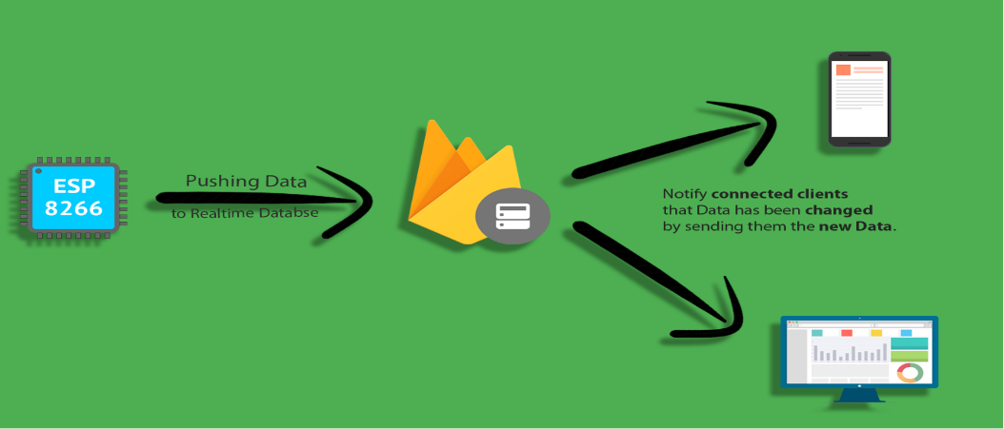
Figure 1: ESP32 Firebase integration for data retrieval

2. Mini-Project 1: Sending Temperature Data to Firebase
In this mini-project, we use an ESP32 to read temperature data and send it to Firebase. The process involves connecting the ESP32 to Firebase, sending temperature data to the cloud, and accessing that data from anywhere, even if the ESP32 and the accessing device are not on the same network.
2-1. ESP32-Firebase Connection
- The ESP32 connects to Firebase to send temperature data. Firebase provides authentication to ensure secure access.
- In the Arduino IDE, code is written to connect the ESP32 to Firebase, allowing it to send temperature data securely.
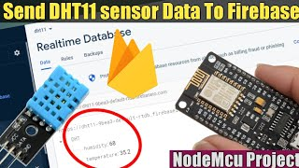

Figure 2: ESP32 integration :Sending Temperature Data to Firebase

2-2. Sending Data to Firebase
- Temperature data is read from the ESP32 and sent to Firebase in real time.
- The real-time database allows data to be accessed from any location, providing flexibility and scalability.
- Only authenticated users can access the data, ensuring security and privacy.
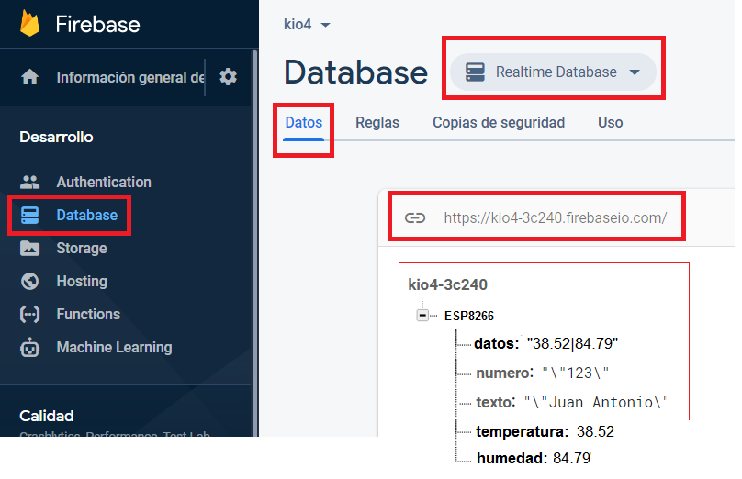
Figure 3: Firebase Real-Time Database
2-3. Accessing Temperature Data
- To access the temperature data, users log in to Firebase and retrieve the data from the database.
- This approach allows access to the data from anywhere in the world, demonstrating the power of cloud computing.

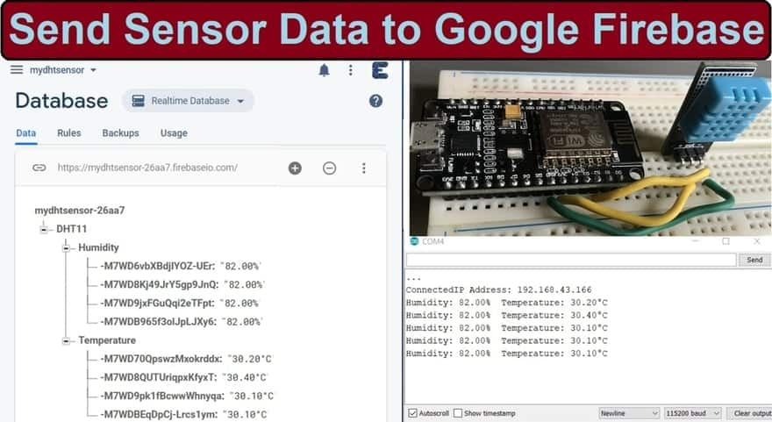
Figure 3: Accessing temperature data through firebase

3. Mini-Project 2: Controlling an LED with Firebase
This mini-project involves using Firebase to control an LED through the cloud. Users can set the state of an LED to "on" or "off" by interacting with Firebase, demonstrating the ability to control devices remotely.
3-1. ESP32-Firebase Connection
- The ESP32 connects to Firebase to send and retrieve data securely.
- In the Arduino IDE, code is written to control the state of an LED based on data retrieved from Firebase.
3-2. Controlling the LED
- The ESP32 checks the state of the LED in the Firebase database and activates or deactivates it accordingly.
- Users can set the state of the LED to "on" or "off" by updating the Firebase database, providing remote control over the device.
3-3. Ensuring Security and Authentication
- Firebase's authentication mechanisms ensure that only authorized users can control the LED.
- The connection between the ESP32 and Firebase is secure, ensuring that data and control instructions are transmitted safely.
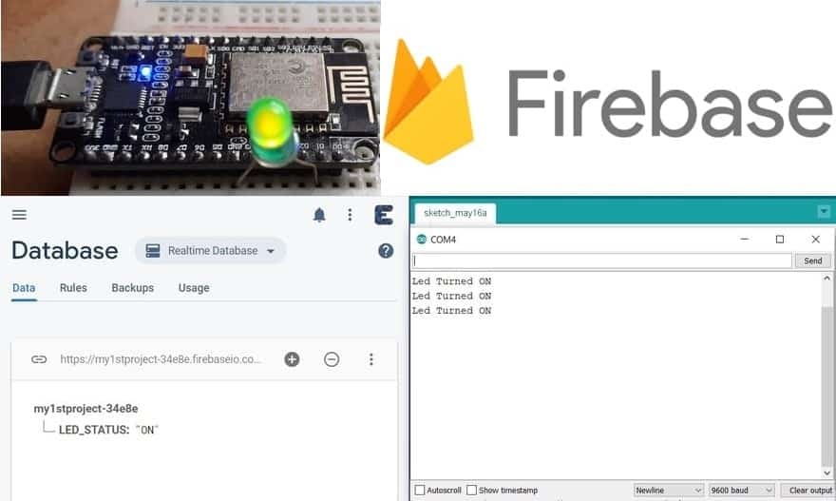
Figure 4 : Controlling LED through Firebase

4. Building User Interfaces with MIT App Inventor
To create a user-friendly interface, we use MIT App Inventor to develop a mobile application that connects to Firebase. This app allows users to retrieve temperature data and control the LED from their phones.
4-1. Creating the Mobile App
- Using MIT App Inventor, we build a mobile app that connects to Firebase using the URL, API address, and secret link of the database.
- The app provides a user-friendly interface for interacting with the IoT project, making it easy to retrieve data and control devices.
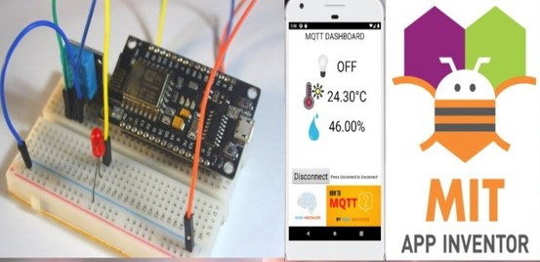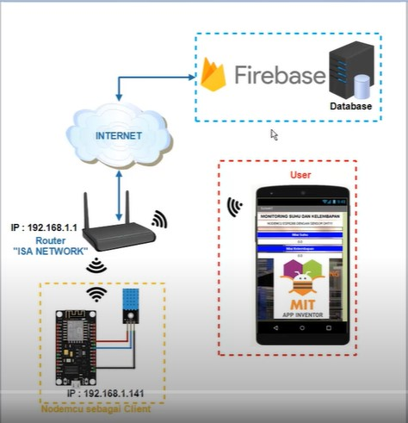
Figure 5: Building a User-Friendly interface with MIT App Inventor and Firebase

4-2. Integrating with Firebase
- The mobile app connects to Firebase to retrieve temperature data and control the LED.
- Only authenticated users can access the Firebase data, ensuring security and privacy.
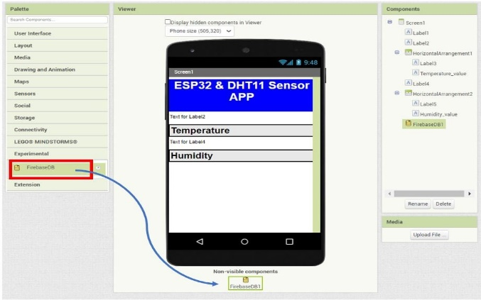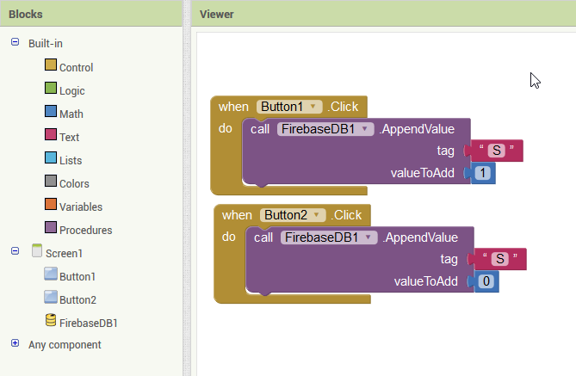
Figure 6: MIT app Inventor : User Interface design and programming

4-3. Interacting with the IoT Project
- Users can retrieve temperature data and control the LED through the mobile app.
- This integration demonstrates the potential of cloud computing, embedded systems, and mobile development, highlighting the flexibility and power of cloud-based IoT projects.
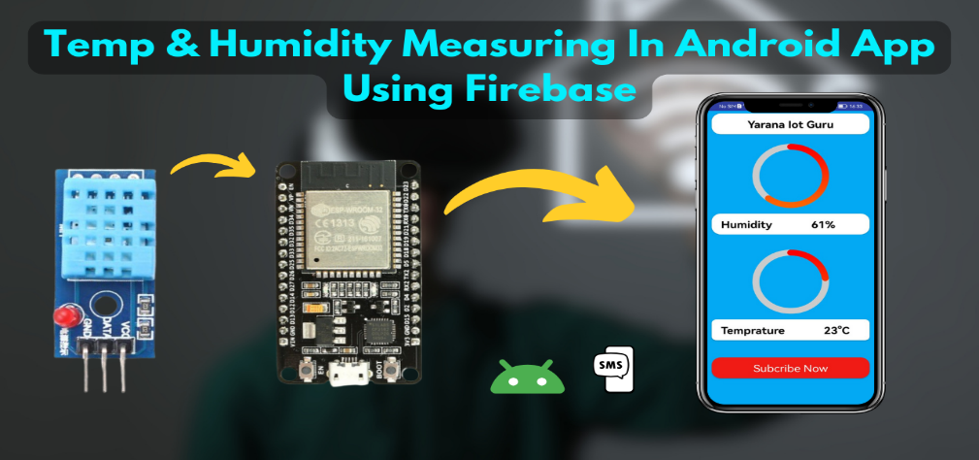

Figure 7: Final Outcome : A functional mobile App
Conclusion
In this chapter, we addressed the limitations of Chapter 1 by using Firebase as a cloud service to enable remote data access and device control. We explored two mini-projects that demonstrated how the ESP32 and Firebase work together to achieve this goal. Additionally, we built a mobile app using MIT App Inventor, providing a user-friendly interface for interacting with the IoT project. By leveraging cloud computing, we unlocked new possibilities for accessing data and controlling devices from anywhere in the world, showcasing the power and flexibility of cloud-based IoT solutions.

